Author: Widmarck Francois

Install and Configure Firewall

Image 1: Software License Agreement

During the pfSense installation, we are first prompted to accept the license agreement. This is a standard step acknowledging the terms before proceeding with installation.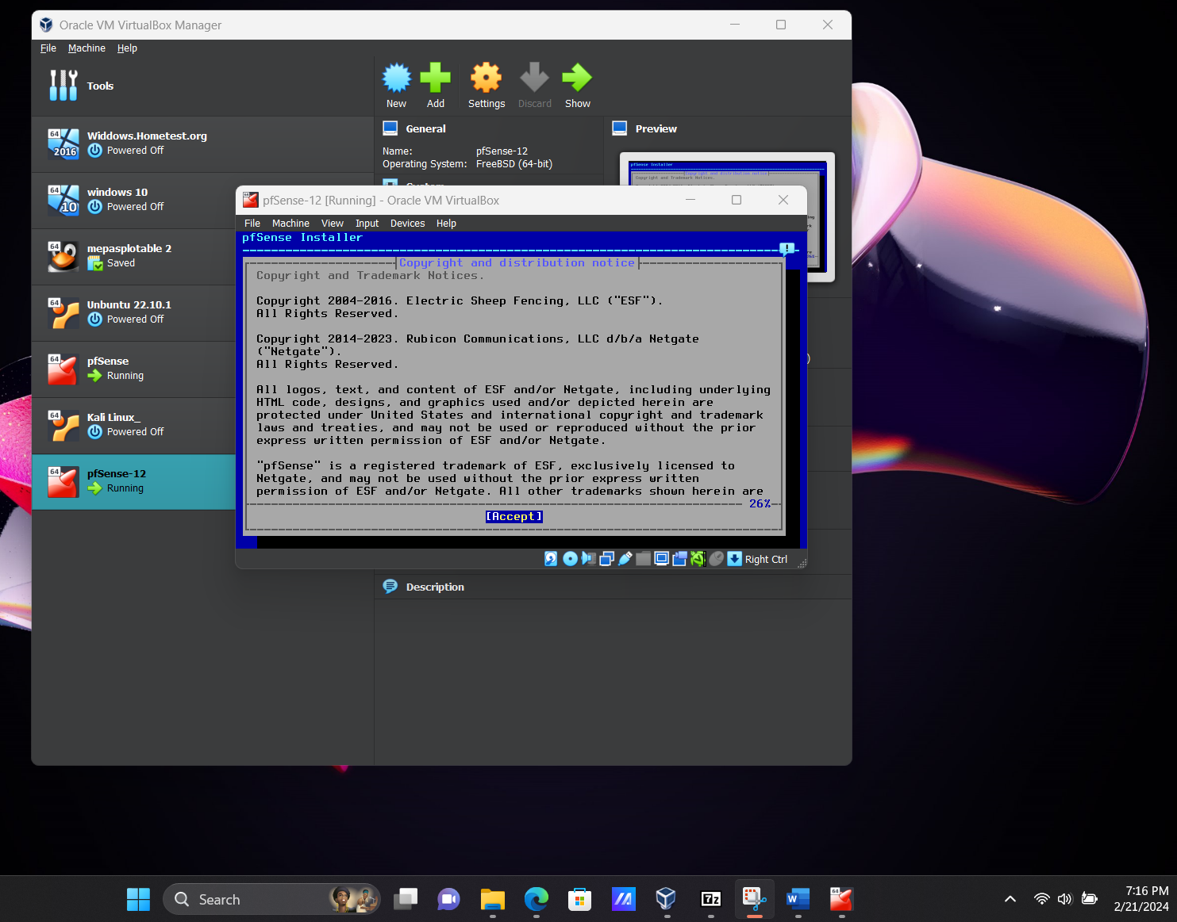

Image 2: Disk Partitioning

Next, the installer prompts us to configure disk partitions. Here, we choose to allow pfSense to automatically partition the virtual disk for the system installation.

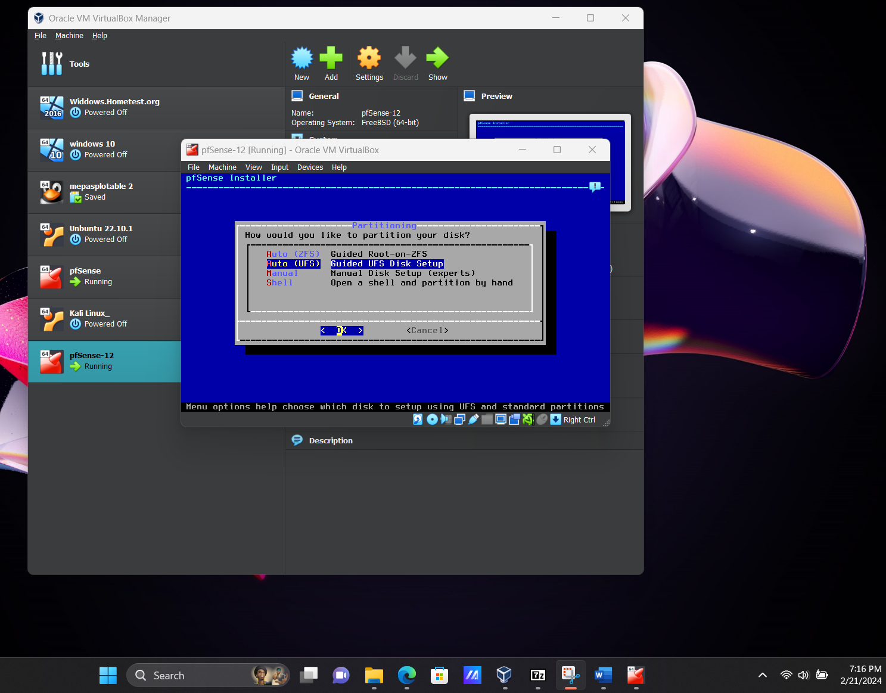

Image 3: Installation Complete

Once pfSense has finished installing, we receive a confirmation message. The system is now ready for reboot to finalize the setup.

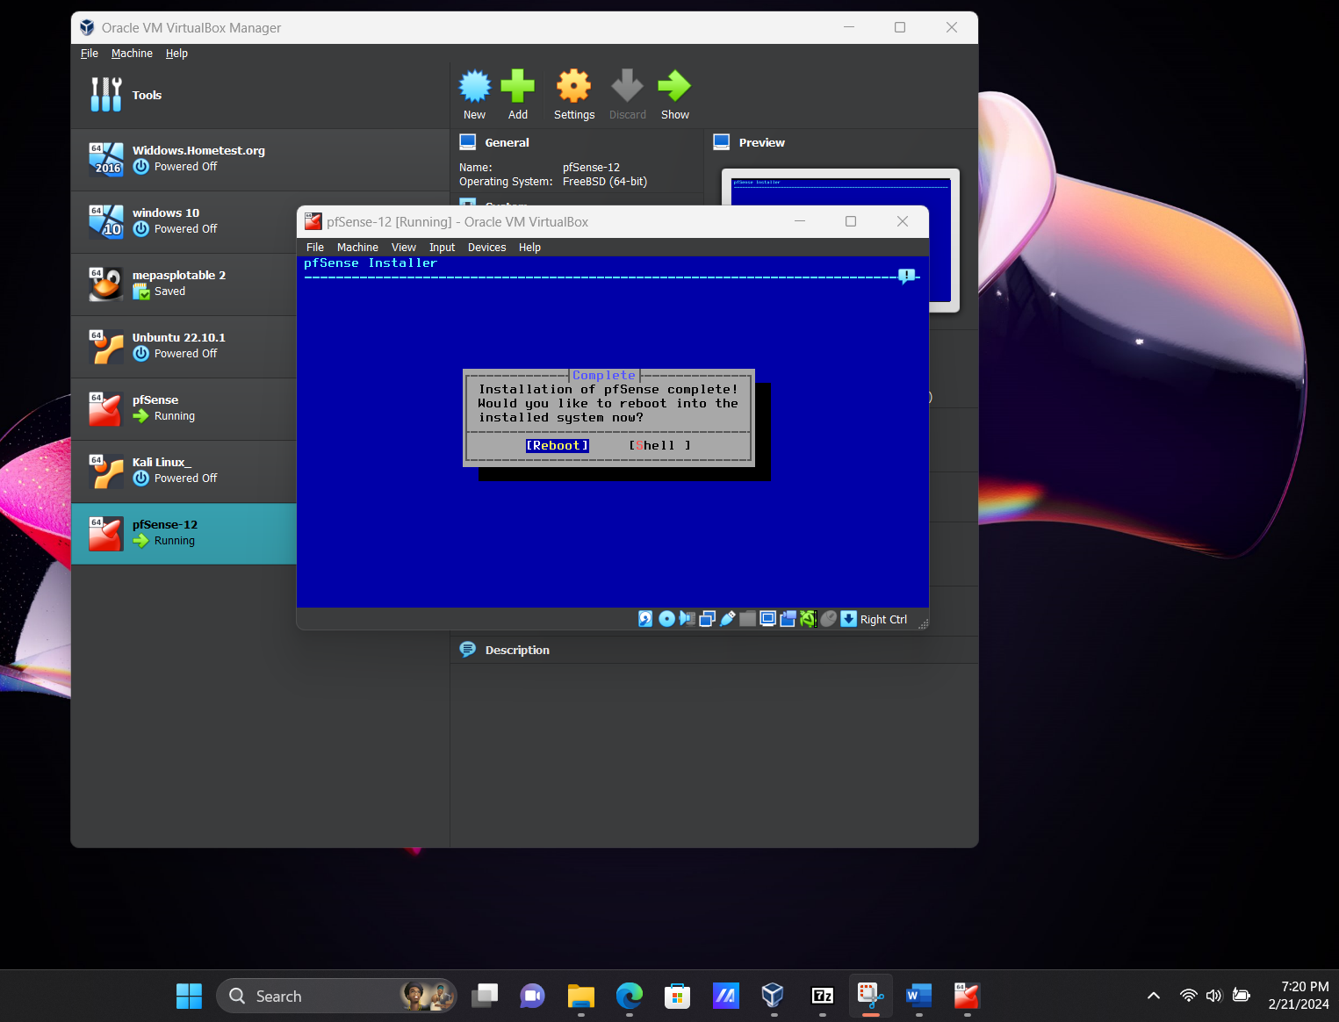

Image 4: pfSense Installed in VirtualBox

After rebooting, pfSense is now successfully installed and running within the VirtualBox environment.

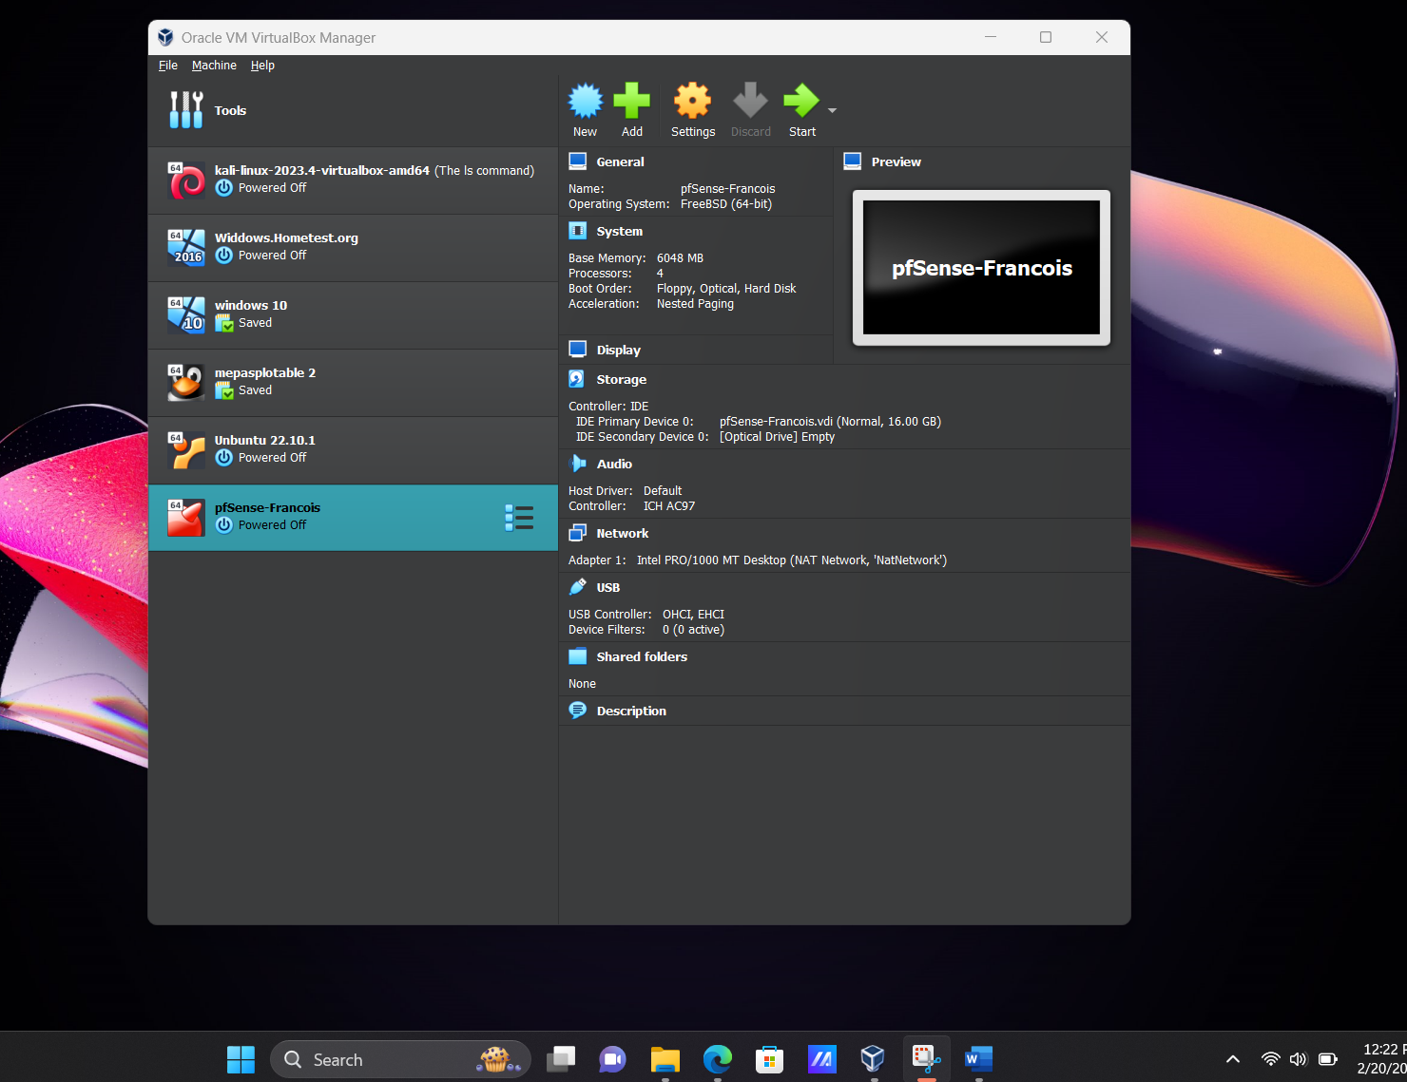

.

Image 5: Network Adapter 1 (WAN) Setup

Adapter 1 is configured to handle outside (WAN) traffic. This interface connects pfSense to the external network or internet.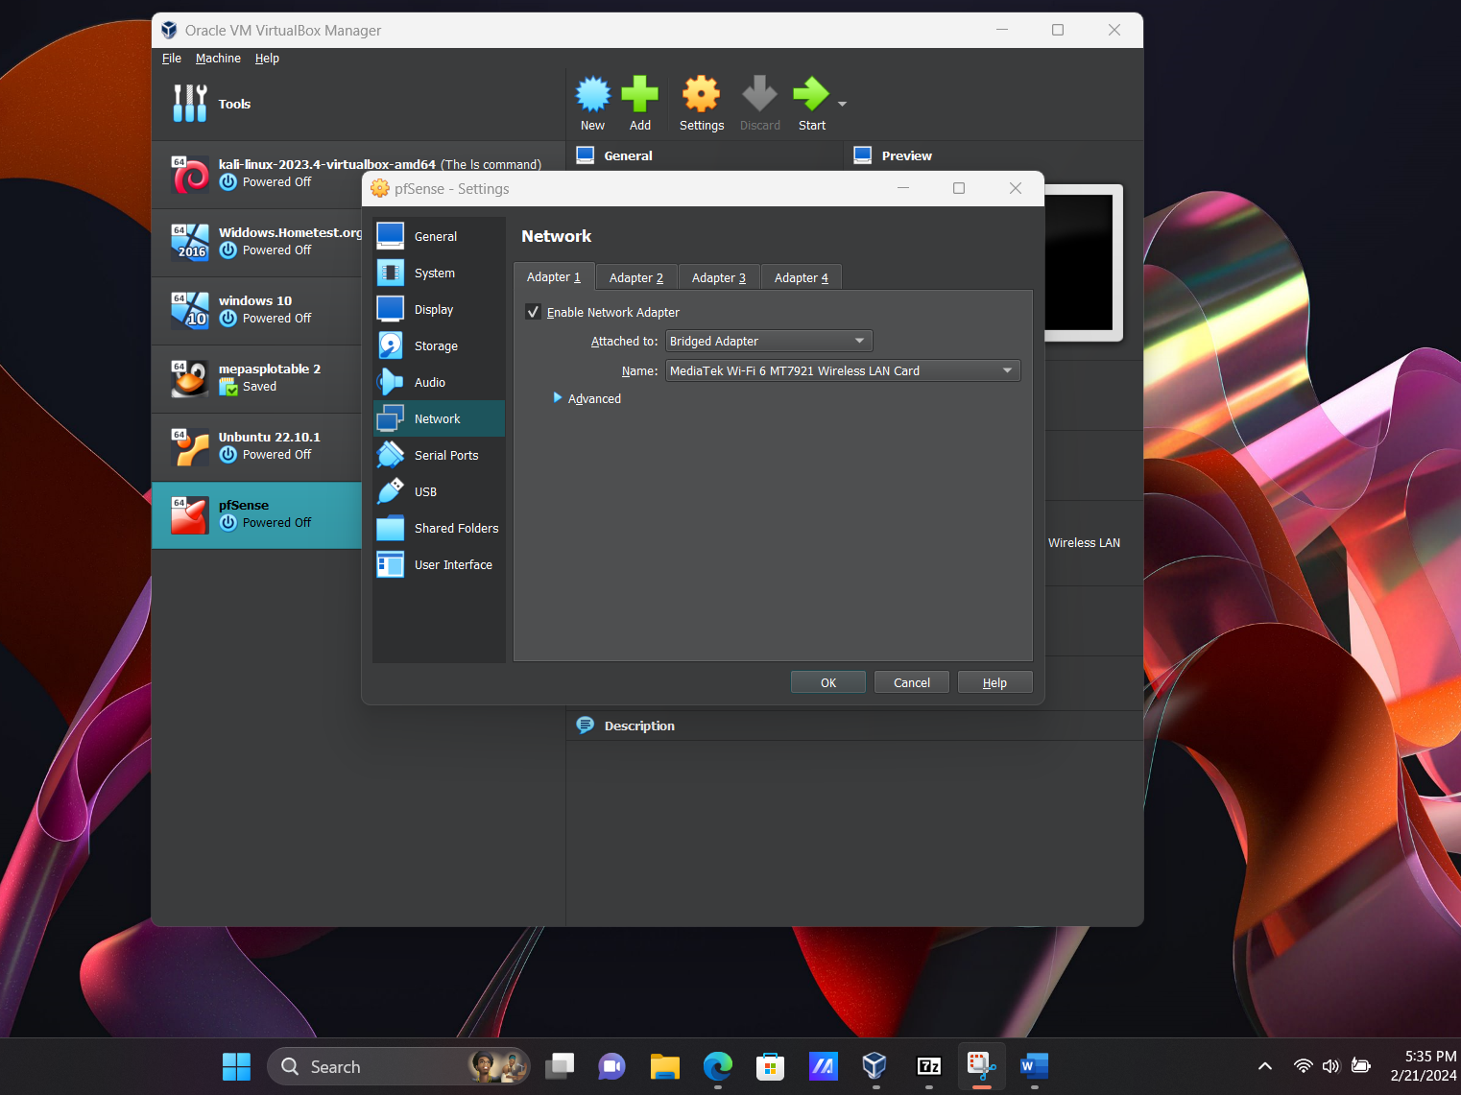

Image 6: Network Adapter 2 (LAN) Setup

Adapter 2 is set up for the internal (LAN) network. This is used to manage and protect internal traffic within the virtual lab environment.

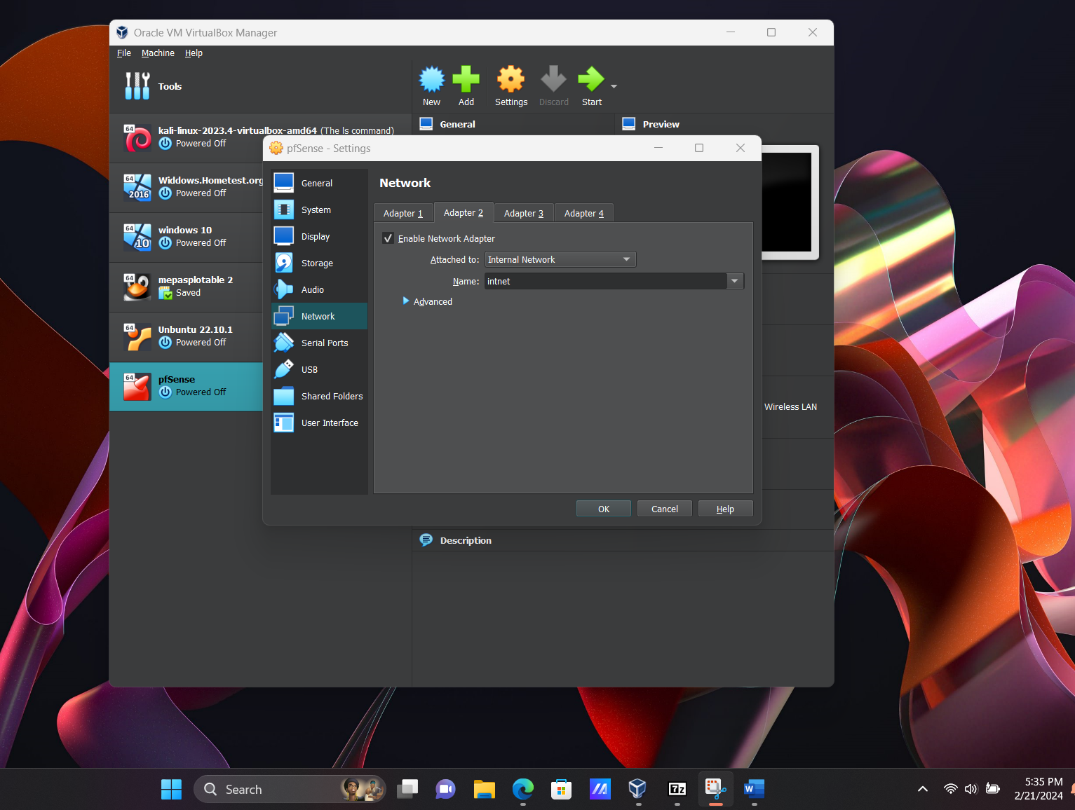

Image 7: Ubuntu Network Setup

An Ubuntu virtual machine is prepared to connect to pfSense. Proper network configuration ensures the Ubuntu system can interact with both the firewall and the internet.

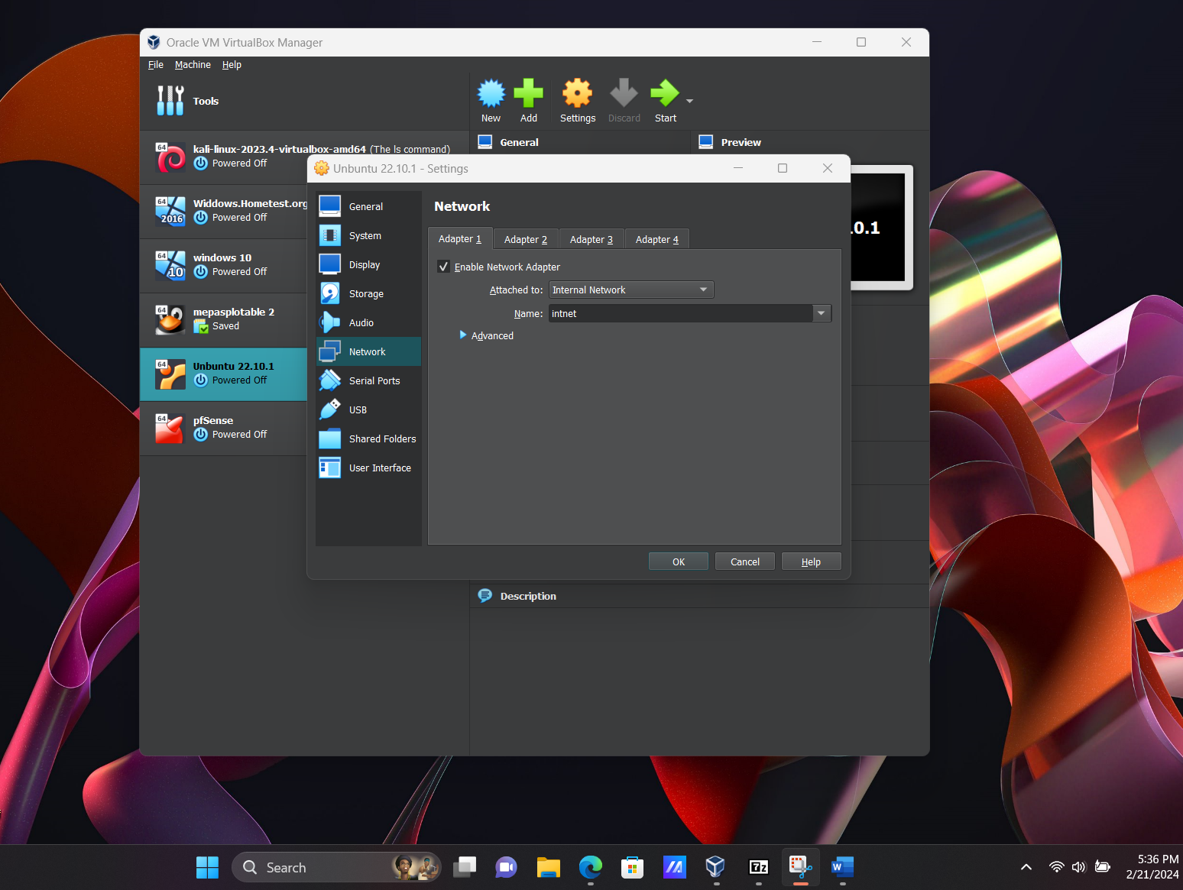

Image 8: WAN and LAN Address Assignment

This image displays the WAN and LAN IP addresses assigned to pfSense. These IPs are critical for accessing the firewall interface and verifying network communication from Ubuntu.

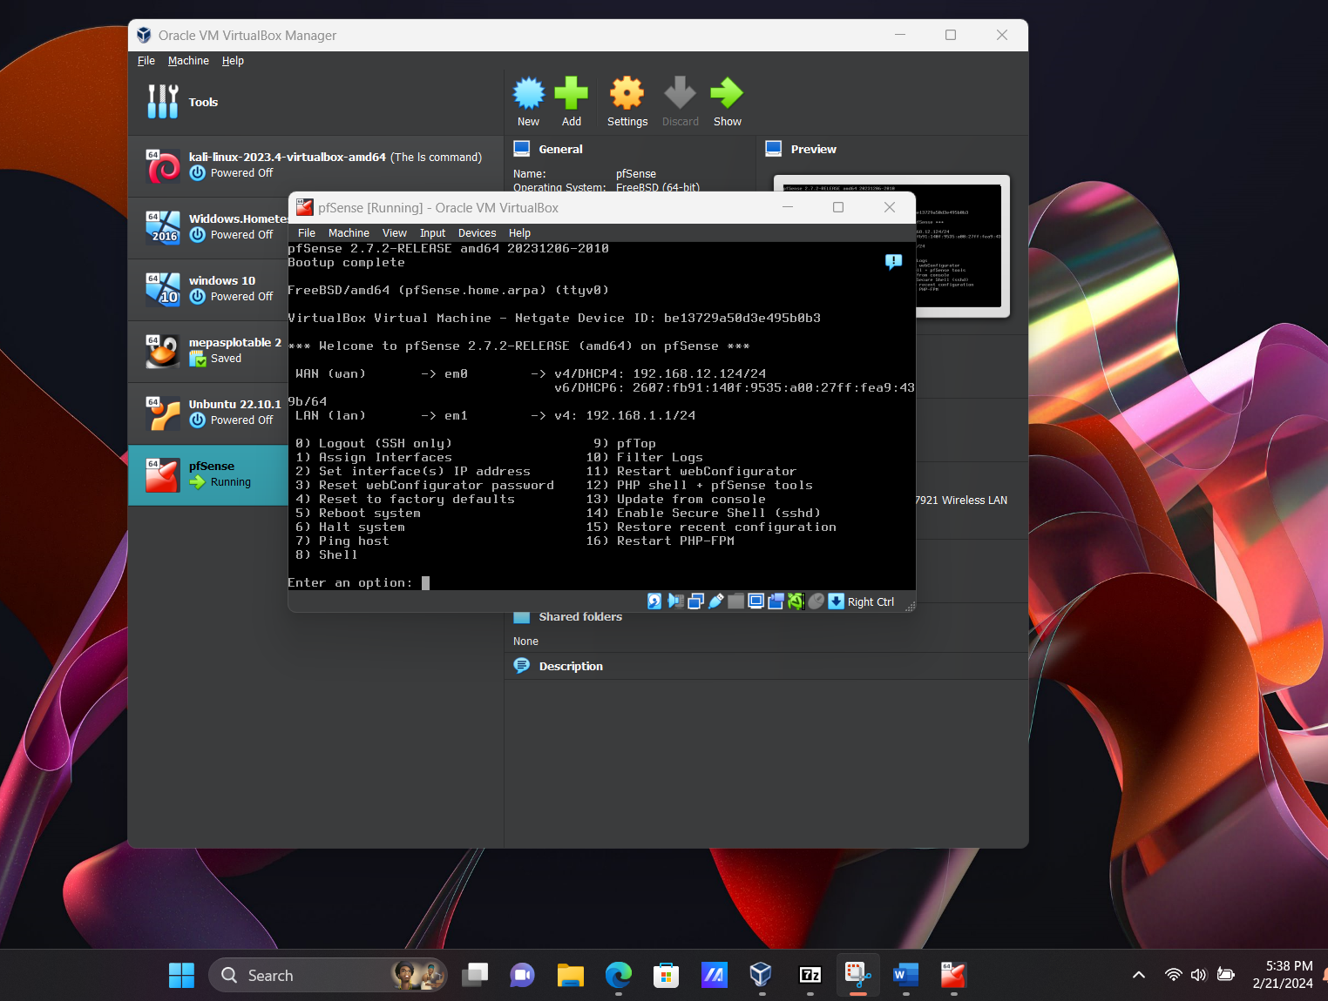

Image 9: DHCP Configuration on Ubuntu

Ubuntu has successfully obtained an IP address via DHCP from the pfSense LAN interface, indicating the firewall is properly distributing network settings.

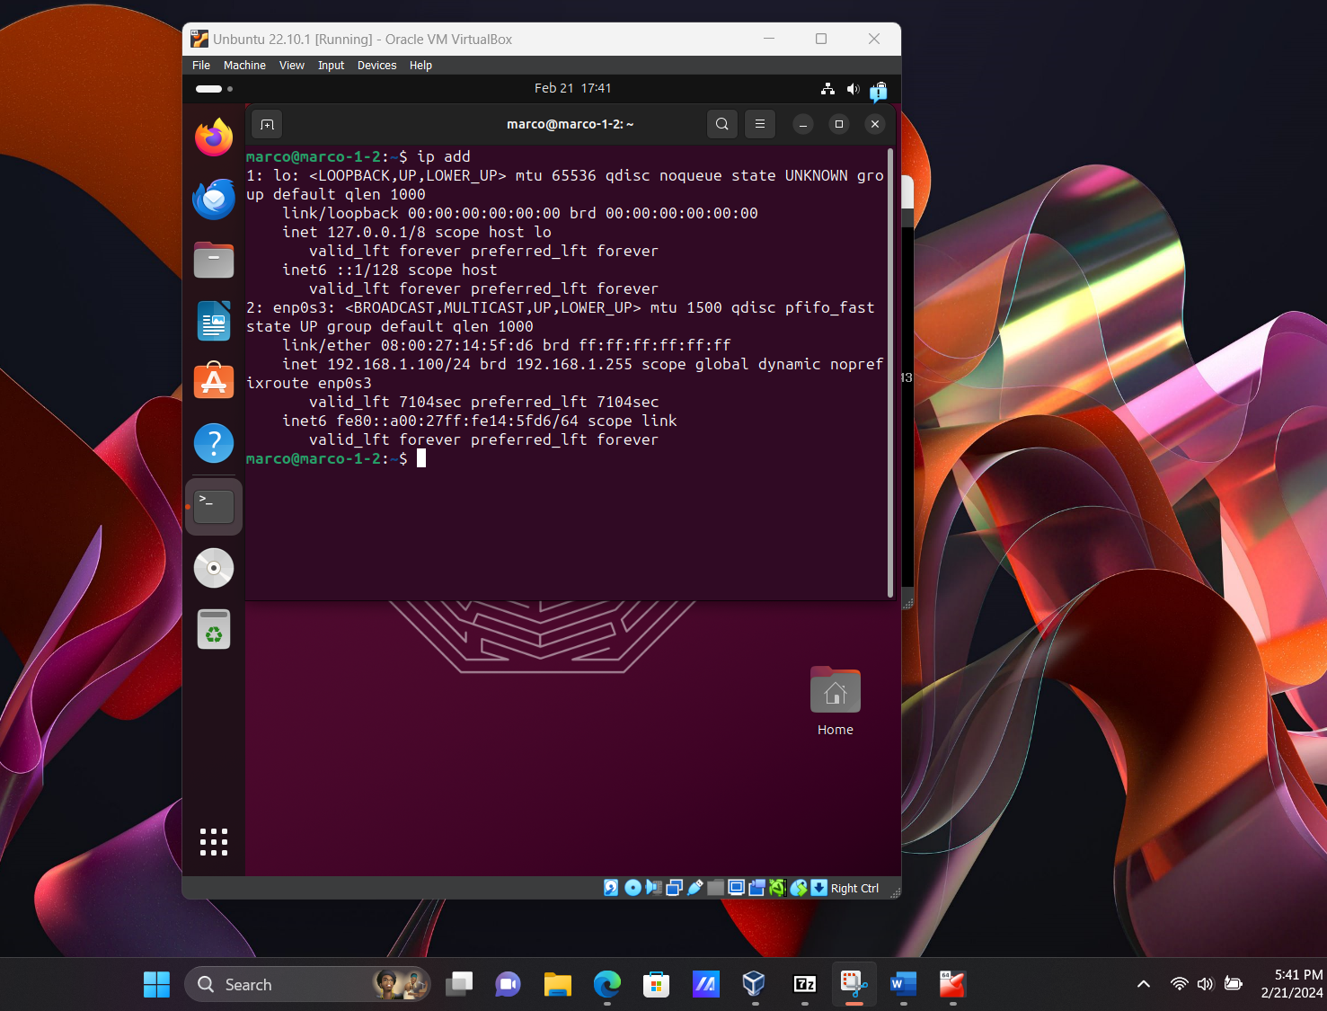

Image 10: Accessing the pfSense Web Interface

Accessing the pfSense web interface confirms that the firewall is active and operational. This login page is used to configure and monitor pfSense features.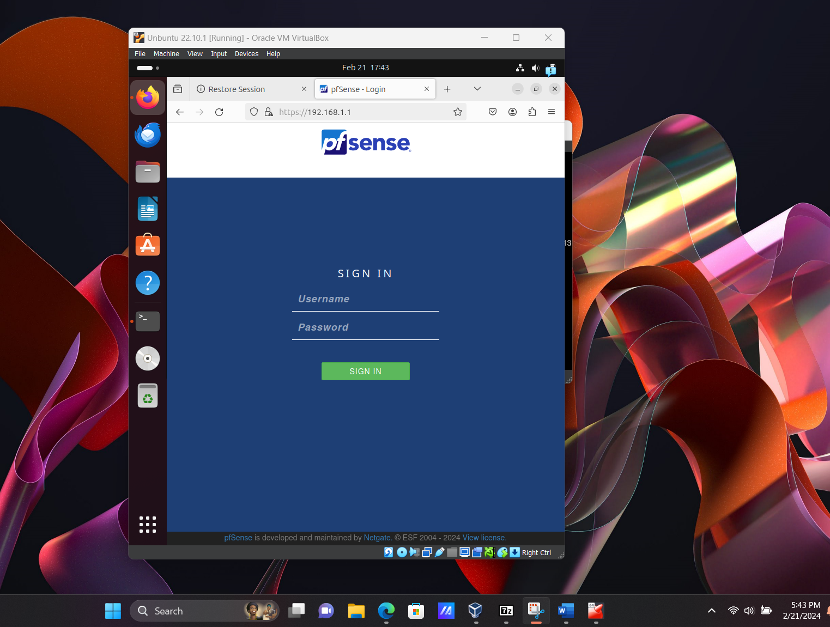

Image 11: Final pfSense Configuration

In the final configuration, we set the hostname and DNS server settings for pfSense. These are essential for naming and internet resolution within the network.

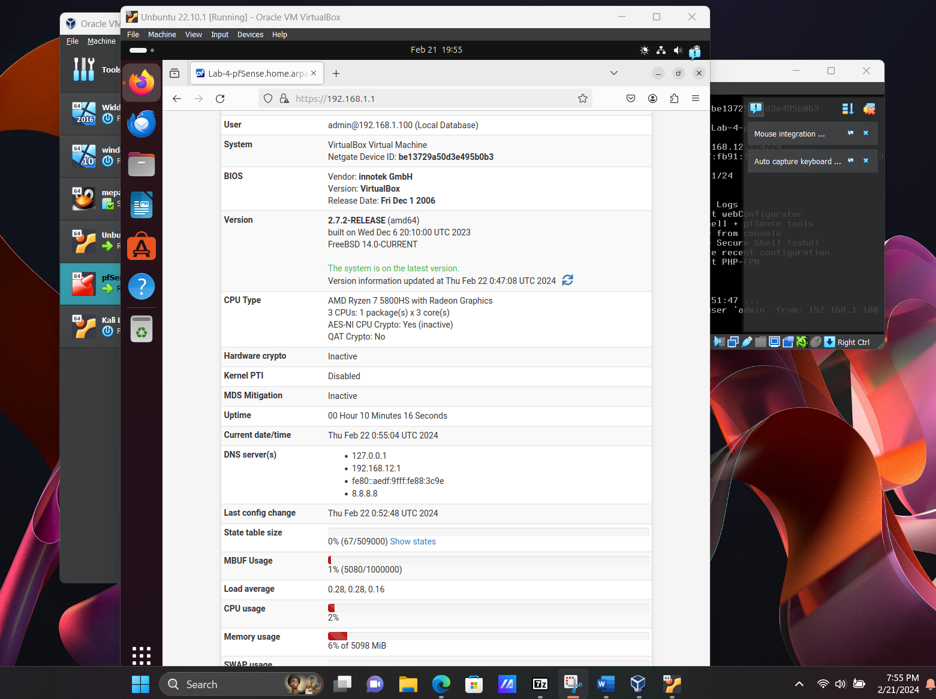

pfSense is very flexible software that is effective in its service, whether as a firewall or a comprehensive security system. Because of its sophisticated capabilities, it differentiates between traffic originating from your internal network of devices and traffic originating from the open internet, allowing you to designate separate rules and policies for each. It is free and open source. The reasons cited above.and many more make it simple to select pfSense.

Of course, I had a few issues in the configuration process. I set the two adapters to work with pfSense, where one is for WAN and the other for LAN. I got as far as the reboot phase and removed the ISO image disk from the file. Unfortunately, after rebooting, the entire process started all over again. And when the pfSense page finally opened, I received a mismatch message about the network.

That forced me to remove and reinstall pfSense. I had better luck that time because it worked the second time around. This time around, I changed a couple of things. First, I changed adapter 1 to a Bridge Adapter and Adapter 2 to the internal network. Additionally, I configured the network on Ubuntu as well; I switched it to Internal Network.